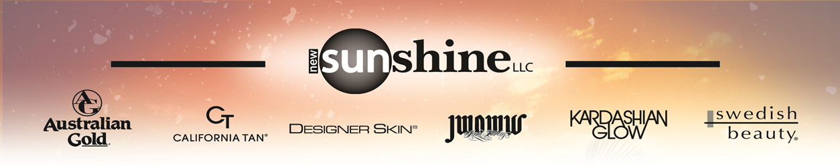
The Importance of Lotion
- What are the three different kinds of tanning available to clients today?
______________________________________________________________________________

- UV light stimulates melanogenisis in what layer of the skin?
  - Dead layer (horny layer)
  - Live layer (germinative layer)

- Tanners should use a tanning lotion when:
  - Tanning indoors
  - Tanning outdoors
  - Sunless tanning
  - All of the above

- True or False: Melanin is your skin’s natural protector. ________________

- True or False: UVB stimulates the production of melanin while UVA oxidizes it. ____________
- What happens to your skin while you tan without tanning lotion?
____________________________________________________________________________________________________________________________________________________________

- True or False: Moisturized skin is more transparent, allowing your skin to produce quicker and darker color.______________________

- What are the benefits of using a tanning lotion?
__________________________________________________________________________________________________________________________________________________________________________________________________________________________________________

- Who should not UV tan?
  - Skin type 2 and tanners taking photo-sensitizing medicine
  - Skin type 1 and skin type 2
  - Skin type 1 and tanners taking photo-sensitizing medicine
  - Skin type 2 and skin type 3
  - All of the above

- What is the New Sunshine difference?
____________________________________________________________________________________________________________________________________________________________

